Product Recall
We have shipped some 1045 that have a defective IR Sensor. Look for an ID number at the side of the sensor (the black canister); if the number is ACF9770008 you do have a defective sensor that will not give the right temperature.
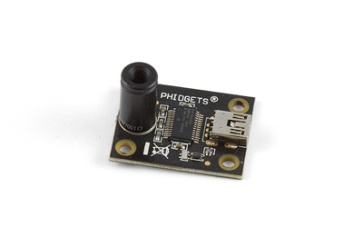
Just email us a picture of your board showing the ID number and the serial number on the back of the board along with a shipping address at support@phidgets.com and we will send you a new sensor.

